**(6115)MAHENDRA INSTITUTE OF ENGINEERING AND TECHNOLOGY**

**SMART PUBLIC RESTROOM**

**Proj_223280_Team_3**

**DOMAIN: INTERNET OF THINGS (IOT)**

**PHASE-2**

**Innovation:**

It demonstrates a practical and sustainable use of technology for public benefit. Also, the solar panels generate electricity during daylight hours, which powers the ventilation system and charges the battery. Air quality sensors continuously monitor the restroom's air for any deterioration in quality. If the sensors detect unpleasant odors or poor air quality, the ventilation system activates to circulate and refresh the air. The automatic air freshener releases a burst of pleasant scent when needed, keeping the restroom smelling fresh.

**Concept of working:**

IoT Device to Monitor the Toilet The MQ-135 sensor detects the stench of the toilet. The presence of ammonia gas in the atmosphere is detected by this sensor. The presence of

Ammonia is responsible for the toilet's foul odor. Ammonia has a pungent odor that can only be perceived at a concentration of 5 parts per million (parts per million). Fans automatically turn on when the ammonia content in the toilet exceeds the set threshold of 5 ppm, while levels below 5 ppm have no impact. Moving on to the next component, an infrared sensor is used to check for the presence of soap in the toilet.

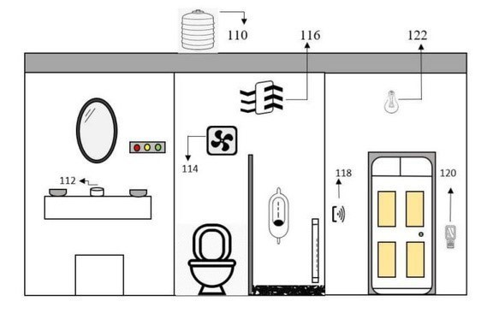

110- Water Tank.

120- Odor detection MQ-135.

112- Soap detector.

122- Automatic lights.

116- Ventilation fan

124- Frequency counter.

126- Cleaners attendance.

**Conclusion:**

The initiative met its goal of creating an economical, user-friendly interface between the cleaning company and public restrooms, allowing for more effective staffing. This program's installation is straightforward. Time series forecasts can be utilized to conduct simultaneous toilet research. If this toilet condition is utilized in the toilet, it assists in keeping the toilet clean before it becomes unclean. The mobile app is considerably easier to use now that the data display has been updated. The Internet of Things device is both inexpensive and portable. In future, this study might be enhanced by employing sensitive and modern sensors to generate more precise data. By learning from sample data and increasing the amount of test data, machine learning increases prediction accuracy. When this approach is used on a large scale, better storage systems and cloud servers can be used.